23CSE202 DATABASE MANAGEMENT SYSTEMS
S3 B.Tech CSE
Department of Computer Science and Engineering
Amrita School of Computing, Amritapuri Campus

3. Database Design Document

Group No : D4
Team Members :
Roll No | Student Name
AM.SC.U4CSE25332 | Mehrin A S
AM.SC.U4CSE25339 | Nithya Ajay
AM.SC.U4CSE25344 | Rudra Rajagopal
AM.SC.U4CSE25356 | Varun Nair

Project Title :

3.1. Detailed description of the project
1. Introduction & Overview
Aureon – Internet Banking System is a database-driven web platform that enables customers to securely access and manage their banking activities online. The system maintains user identity and authentication information, customer profiles, bank accounts, cards, beneficiaries, bills, fund transfers, transactions and transaction history, while providing configurable settings and administrative controls. The database is designed to preserve financial data integrity, enforce authorization rules, and maintain an auditable record of banking operations.
2. The Users
- Customers: Registered users who authenticate into Aureon, manage their profile and settings, view accounts and cards, add beneficiaries, pay bills, initiate transfers, and view transaction history.
- Admin: Users who manage operational records and system data according to their assigned role and permissions.
3. User, Authentication & Profile Management
The USER entity stores the core identity and contact information of a registered person. LOGIN_CREDENTIALS stores authentication-related data separately from personal information, including username, password , login timestamps and failed-attempt information. Each user has one profile containing optional personal and preference information and one settings record containing application, notification, language and security preferences.
4. Accounts, Cards & Banking Relationships
An ACCOUNT represents a bank account owned by a user. Each account has a unique account number and stores its account type, balance, opening date, status and. A user may own multiple accounts. A CARD is issued against an account and stores card number, card type, expiry information, status and other security-related attributes. The design separates card information from account information to reduce redundancy and support multiple cards per account.
5. Beneficiaries, Transfers & Transactions
Users can create BENEFICIARY records for recipients to whom funds may be transferred. A TRANSFER represents a fund-transfer operation and is modeled as a ternary relationship involving the source ACCOUNT, BENEFICIARY and TRANSACTION. The TRANSFER relation stores transfer-specific attributes such as amount, transfer date, remarks and status. TRANSACTION stores the authoritative financial event, including transaction type, amount, timestamp, balance after the event, description, status and reference information.
6. Transaction History, Bills & Settings
TRANSACTION_HISTORY is modeled as a weak entity dependent on TRANSACTION, allowing multiple historical-view records to be associated with a transaction while retaining the identifying transaction key. BILL stores biller information, the account used for payment, amount, due date and payment status. SETTINGS stores user-specific application and security preferences.
7. Administrative Management
ADMIN represents privileged administrative users. The administrator can manage selected operational records such as users, accounts, transactions, beneficiaries, bills, cards and settings, subject to role-based authorization. Administrative activity is conceptually separated from customer activity so that access control and responsibilities can be enforced.
8. Specific Business Rules & Database Constraints
- Every USER has a unique user_id; email is unique and username is unique within LOGIN_CREDENTIALS.
- Each USER has exactly one LOGIN_CREDENTIALS record, one PROFILE record and one SETTINGS record.
- A USER can own one or more ACCOUNT records, while each ACCOUNT belongs to exactly one USER.
- An ACCOUNT may have multiple CARD records; each CARD is linked to exactly one ACCOUNT.
- Each TRANSACTION belongs to exactly one ACCOUNT, and a transaction may have multiple transaction-history records.
- A completed debit transfer must not reduce an account balance below the permitted minimum; transaction status must reflect success or failure.
- A BILL belongs to one USER and may reference the ACCOUNT from which the bill is paid.
- ADMIN access is privileged and must be restricted according to the administrator's role.
- Primary keys uniquely identify records; foreign keys enforce referential integrity between related entities.

3.2. ER Diagram
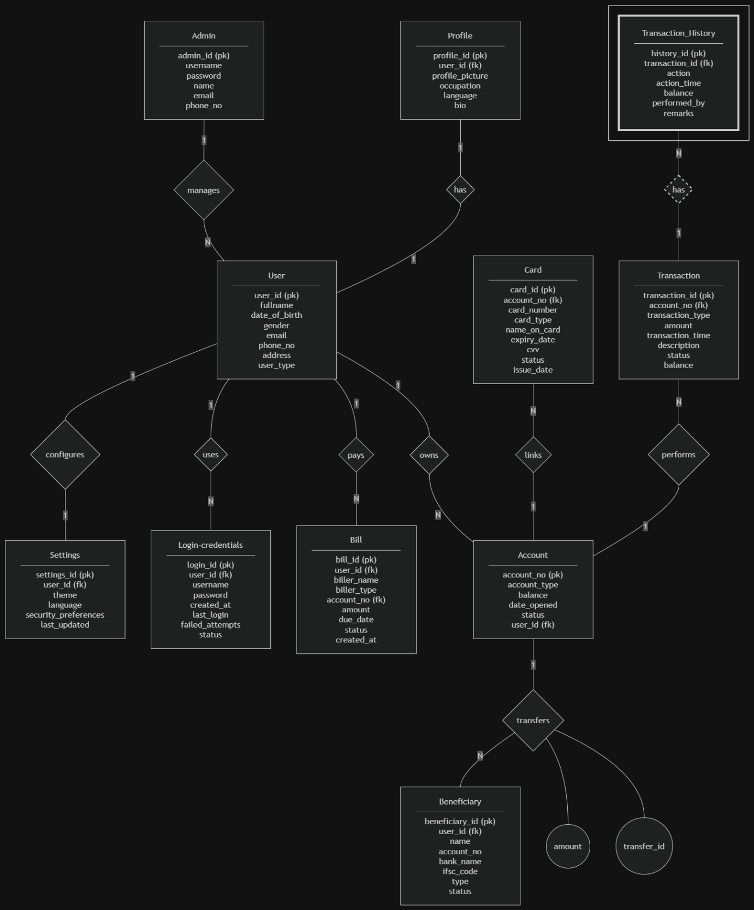

3.3 Relational Schema
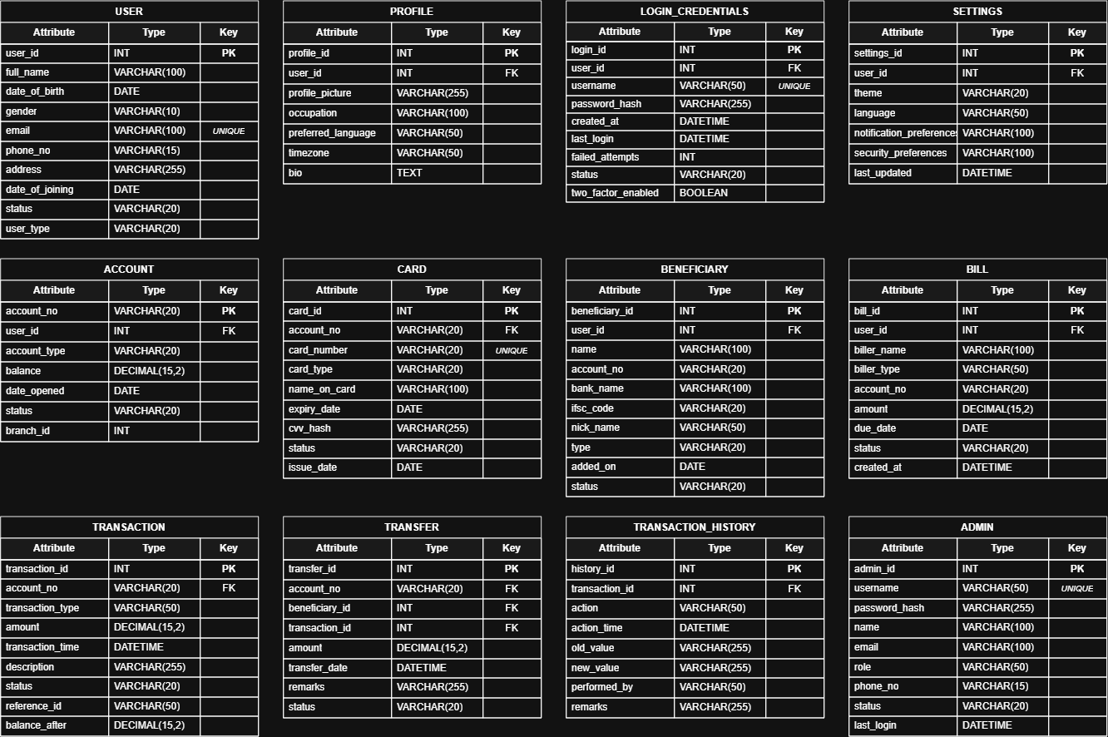

3.4 Normalization and Functional dependency analysis
FUNCTIONAL DEPENDENCIES
- User
user_id {full_name, date_of_birth, gender, email, phone_no, address, user_type}
email { user_id, full_name, date_of_birth, gender, phone_no, address, user_type}

- Login
Login_id { user_id, username, password, created_at, last_login, failed_attempts, status}

- Settings
Settings_id { user_id, theme, , language, security_preferences, last_updated}

- Admin
Admin_id {username, password, name, email, phone_no}

- Bill
bill_id {user_id, biller_name, biller_type, account_no, amount, due_date, status, created_at}

- Profile
Profile_id {user_id, profile_picture, occupation, language, bio}

- Account
Account_no {account_type, balance, date_opened, status, user_id}

- Card
Card_id {account_no, card_number, card_type, name_on_card, expiry_date, cvv, status, issue_date}

- Beneficiary
Beneficiary_id {user_id, name, account_no, bank_name, ifsc_code, type, status}

- Transaction
Transaction_id {account_no, transaction_type, amount, transaction_time, description, status, balance}

- Transaction_History
(history_id, transaction_id) {action, action_time, balance, performed_by, remarks}

CANDIDATE KEYS
- User – user_id, email
- Login – login_id, user_id
- Bill – bill_id, user_id, account_no
- Settings – settings_id, user_id
- Admin – admin_id, username, email
- Profile – profile_id, user_id
- Account – account_no, user_id
- Card – card_id, account_no
- Beneficiary – beneficiary_id, user_id, account_no
- Transaction – transaction_id, account_no
- Transaction_History – (history_id, transaction_id)

CONVERSION TO FIRST NORMAL FORM
A relation is in 1NF when each attribute contains a single atomic value and repeating or multivalued attributes are removed. The repeating groups in the UNF representation are separated into individual relations.
- User(user_id, full_name, date_of_birth, gender, email, phone_no, address, user_type)
- Login_Credentials (login_id, user_id, username, password, created_at, last_login, failed_attempts, status)
- Profile(profile_id, user_id, profile_picture, occupation, preferred_language, bio)
- Settings (settings_id, user_id, theme, language, security_preferences, last_updated)
- Account (account_no, user_id, account_type, balance, date_opened, status)
- Card (card_id, account_no, card_number, card_type, name_on_card, expiry_date, cvv, status, issue_date)
- Beneficiary (beneficiary_id, user_id, name, account_no, bank_name, ifsc_code, status)
- Bill (bill_id, user_id, biller_name, biller_type, account_no, amount, due_date, status, created_at)
- Transaction (transaction_id, account_no, transaction_type, amount, transaction_time, balance_after, description, status, reference_id)
- Transfer (transfer_id, account_no, beneficiary_id, transaction_id, amount, transfer_date, remarks, status)
- Transaction_History(transaction_id, history_id, viewed_at, viewed_by)
- Admin (admin_id, username, password, name, email, phone_no, status, last_login)
All attributes are now atomic and repeating groups have been removed. Therefore, the relations satisfy 1NF.

CONVERSION TO 2NF
A relation is in Second Normal Form (2NF) when it is already in 1NF and every non-prime attribute is fully functionally dependent on the entire candidate key. Here, most relations use a single identifier, so those relations already satisfy 2NF once 1NF is achieved.
- USER
User (user_id, full_name, date_of_birth, gender, email, phone_no, address, user_type). Candidate key: user_id. The dependency user_id → all remaining attributes is a full dependency on a single-attribute key. Since a partial dependency requires a composite key, USER has no partial dependency and is in 2NF.

- LOGIN_CREDENTIALS
Login_Credentials (login_id, user_id, username, password, created_at, last_login, failed_attempts, status). Candidate key: login_id. All authentication attributes depend on login_id as a whole. Therefore no partial dependency is possible and the relation is in 2NF.
- PROFILE
Profile (profile_id, user_id, profile_picture, occupation, preferred_language, bio). Candidate key: profile_id. The profile attributes depend fully on profile_id. Hence PROFILE is in 2NF.
- SETTINGS
Settings(settings_id, user_id, theme, language, security_preferences, last_updated). Candidate key: settings_id. Every setting attribute is determined by settings_id, so there is no partial dependency. SETTINGS is in 2NF.
- ACCOUNT
Account (account_no, user_id, account_type, balance, date_opened, status,). Candidate key: account_no. The account attributes depend on the complete account number. Therefore ACCOUNT is in 2NF.
- CARD
Card (card_id, account_no, card_number, card_type, name_on_card, expiry_date, cvv, status, issue_date). Candidate key: card_id. All card-specific attributes depend on card_id. Thus CARD is in 2NF.
- BENEFICIARY
Beneficiary (beneficiary_id, user_id, name, account_no, bank_name, ifsc_code, status). Candidate key: beneficiary_id. All beneficiary attributes depend on the complete identifier, so no partial dependency exists. BENEFICIARY is in 2NF.
- BILL
Bill (bill_id, user_id, biller_name, biller_type, account_no, amount, due_date, status, created_at). Candidate key: bill_id. Bill details depend fully on bill_id. Therefore BILL is in 2NF.
- TRANSFER
TRANSFER(transfer_id, source_account_no, beneficiary_id, transaction_id, amount, transfer_date, remarks, status). Candidate key: transfer_id. The transfer attributes are determined by transfer_id. The ternary nature of the transfer relationship is represented by its foreign keys, but it does not create a partial dependency because the relation uses a single-attribute key. TRANSFER is in 2NF.
- TRANSACTION
Transaction (transaction_id, account_no, transaction_type, amount, transaction_time, balance_after, description, status, reference_id). Candidate key: transaction_id. Every transaction attribute depends on transaction_id, so there is no partial dependency. TRANSACTION is in 2NF.
- TRANSACTION_HISTORY
Transaction_History (transaction_id, history_id, viewed_at, viewed_by). Because history_id is a weak identifier whose meaning is tied to its owning transaction, the identifying key is (transaction_id, history_id). The dependencies are (transaction_id, history_id) → viewed_at, viewed_by. Neither transaction_id alone nor history_id alone determines viewed_at or viewed_by. Thus the non-key attributes depend on the complete composite key and TRANSACTION_HISTORY is in 2NF.
- ADMIN
Admin (admin_id, username, password, name, email, phone_no, status, last_login). Candidate key: admin_id. All administrator attributes depend fully on admin_id, so no partial dependency exists. ADMIN is in 2NF.

CONVERSION TO 3NF
Third Normal Form (3NF) requires a relation to be in 2NF and to contain no transitive dependency in which a non-key attribute determines another non-key attribute.
- USER
Dependency: user_id → full_name, date_of_birth, gender, email, phone_no, address, user_type. The determinant user_id is the candidate key and no non-key attribute is used to determine another non-key attribute. USER is therefore in 3NF.
- LOGIN_CREDENTIALS
Dependency: login_id → user_id, username, password, created_at, last_login, failed_attempts, status. Authentication attributes are determined directly by login_id. The presence of user_id as a foreign key identifies the associated user but does not determine another non-key attribute inside LOGIN_CREDENTIALS. Hence it is in 3NF.
- PROFILE
Dependency: profile_id → user_id, profile_picture, preferred_language, bio. All profile information is directly dependent on profile_id. No profile attribute determines another non-key attribute. PROFILE is in 3NF.
- SETTINGS
Dependency: settings_id → user_id, theme, language, security_preferences, last_updated. Each setting belongs to the identified settings record. There is no dependency such as theme → language or language → security_preferences. SETTINGS is in 3NF.
- ACCOUNT
Dependency: account_no → user_id, account_type, balance, date_opened, status. Account properties are determined by account_no. User is referenced through foreign keys rather than storing their descriptive details in ACCOUNT. Thus no transitive dependency is present and ACCOUNT is in 3NF.
- CARD
Dependency: card_id → account_no, card_number, card_type, name_on_card, expiry_date, cvv, status, issue_date. Card details depend directly on card_id. Account information is referenced using account_no rather than duplicating USER or ACCOUNT descriptive attributes. CARD is in 3NF.
- BENEFICIARY
Dependency: beneficiary_id → user_id, name, account_no, bank_name, ifsc_code, status. The beneficiary record is identified by beneficiary_id and its stored attributes describe that beneficiary entry. No non-key attribute is used as a determinant of another non-key attribute. BENEFICIARY is in 3NF.
- BILL
Dependency: bill_id → user_id, biller_name, biller_type, account_no, amount, due_date, status, created_at. Bill information is directly determined by bill_id. User and account references are stored as foreign keys, preventing duplication of their independent attributes. BILL is in 3NF.
- TRANSFER
Dependency: transfer_id → source_account_no, beneficiary_id, transaction_id, amount, transfer_date, remarks, status. All facts about a transfer event are dependent on transfer_id. The three foreign keys identify the participants of the ternary transfer relationship; their descriptive data remains in the corresponding relations. Therefore TRANSFER is in 3NF.
- TRANSACTION
Dependency: transaction_id → account_no, transaction_type, amount, transaction_time, balance_after, description, status, reference_id. Transaction attributes are directly dependent on transaction_id. No non-key attribute such as transaction_type or status determines another non-key attribute. TRANSACTION is in 3NF.
- TRANSACTION_HISTORY
Dependency: (transaction_id, history_id) → viewed_at, viewed_by. The history attributes depend on the complete identifying key. No non-key attribute determines another non-key attribute. Therefore the weak TRANSACTION_HISTORY relation is in 3NF.
- ADMIN
Dependency: admin_id → username, password, name, email, role, phone_no, status, last_login. All administrator details are determined directly by admin_id. Role and status are descriptive properties rather than determinants of other attributes. ADMIN is in 3NF.

BCNF ANALYSIS
A relation is in Boyce–Codd Normal Form (BCNF) when, for every non-trivial functional dependency X → Y, X is a superkey. The finalized Aureon relations satisfy this condition under the stated business rules and UNIQUE constraints.
Relation | BCNF Justification
USER | user_id determines all user attributes; email is an alternate unique identifier when enforced as UNIQUE NOT NULL. Both determinants are candidate keys.
LOGIN_CREDENTIALS | login_id and username are candidate keys under the stated UNIQUE constraint, and user_id is also unique because each user has one credential record.
PROFILE / SETTINGS | profile_id and user_id are candidate keys because the USER–PROFILE and USER–SETTINGS relationships are 1:1.
ACCOUNT / CARD / BENEFICIARY / BILL / TRANSACTION / ADMIN | Their primary identifiers determine all non-key attributes, and no non-key determinant is introduced.
TRANSFER | transfer_id determines the relationship attributes; transaction_id is an alternate key when one transaction represents one transfer.
TRANSACTION_HISTORY | (transaction_id, history_id) is the identifying key of the weak entity; no non-key determinant exists.
Thus, the finalized relational design can be considered in BCNF.

